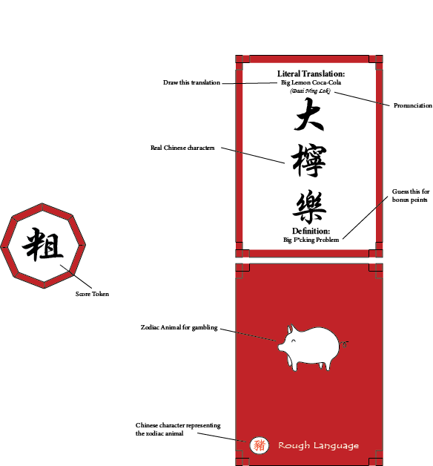

* Each player takes turns drawing a card from the top of the deck.
* The player whose turn it is must read the **Literal Meaning**on the top of the face side and draw what is described on the card within **45 seconds**. No words can be written except logos. **Do not show other players!**
* Reveal what you have drawn to the other players, they will have **1 minute** to guess the meaning of the drawing.
* The drawer may assist by circling specific elements or adding small additions to the drawing.
* If the meaning is close enough for example “Large Lime Pepsi” instead of “Big Lemon Coke” the drawer can award the point. This is a guideline, but ultimately the drawer can award points as they see fit.
* The first player to guess the drawing, and the player who drew the picture are awarded 1 **Score Token** each.
  + Players should decide at the beginning of the game if points should be awarded for **Definition** guesses.
  + (Optional) for bonus points allow guessers **1 guess** at the **Definition.**
  + Correct guesses award the player **2 Score Tokens.**
  + The **Definition** is located at the bottom of the card.
* The player who guessed the **Literal Meaning** correctly receives the card at the end of the turn. Keep the card faced up to prevent other players from seeing the zodiac.
* Otherwise, if no player is able to guess the card in 1 minute no points are allotted and the card is discarded.
* Every **5 turns**, **Gambling Phase** is initiated.
  + Players have the option to choose a card to place that they have collected during the game.
  + Keep your chosen card concealed and countdown. After **5 seconds**, place the chosen card in the center.
  + Additional **Score Tokens** are distributed and lost depending on what other players place.
  + Green slots on the **Compatibility Chart** give 1 **Score Token**, red slots cause players to lose 1 **Score Token**, and yellow slots give 2 **Score Tokens** if the card exists on the field or causes players to lose 1 **Score Token** if it doesn't.
* Follow the chart and match what other players have placed in comparison to the zodiac animal the player has played.
  + Example: Player 1 places Rat, while other players play Ox, Tiger, Rabbit, and Horse.
  + Player 1 is awarded 0 **Score Tokens**. 2 **Score Tokens** are gained from Ox and Rabbit, 0 **Score Tokens** are gained from Tiger, 1 **Score Token** is loss because of Horse, and since Goat does not exist on the field 1 **Score Token** is loss.
* Withdraw and keep the card after **Gambling Phase** has ended.
* Players should decide how many points are needed to win at the start of the game.

**Compatibility Chart**

Machine generated alternative text:
Ter 
Ter 
Rabbit 
Dragon 
Snake 
Horse 
2/-1 
Monkey 
Rooster 
2/-1 
Rabbit 
Dragon 
Snake 
Horse 
Goat 
Monkey 
-1 2/-1 
Rooster 
Dog 
o 
Pig 
2/-1 